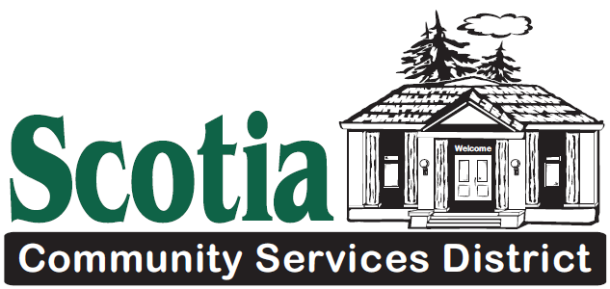

Notice is hereby given that a
REGULAR MEETING
Of the Board of Directors will be held at:
400 Church Street, Scotia, CA 95565
Thursday, October 15, 2020
Regular Meeting at 5:30 P.M.
AGENDA
- CALL TO ORDER/ ROLL CALL The Presiding Officer will call the meeting to order and the Board Clerk will call the roll of members to determine the presence of a quorum. PLEASE REMEMBER TO SILENCE ALL CELL PHONES
In accordance with the Governor’s Executive Orders N-25-20 and N-29-20 SCSD Board of Directors shall conduct the District’s business via teleconference as the Board chambers are closed at this time. This meeting may be accessed by using the following call-in number: 1 669 900 6833. When prompted enter the meeting i.d. 813 4311 0300 and the following password 744468. Please submit public comments in writing 24 hours ahead of the meeting, if possible. If anyone who wishes to teleconference the meeting and has ADA access needs, please call the SCSD Administrative Office not less than 24 hours in advance of the meeting time to make accommodations.
PLEDGE OF ALLEGIANCE
- SETTING OF AGENDA The Board may adopt/revise the order of the agenda as presented
- CONSENT CALENDAR Consent Calendar items are routine, to be acted upon by the Board of Directors at one time without discussion. If any Board member, staff member, or interested person requests that an item be removed from the Consent Calendar, it shall be moved so that it may be acted upon separately in business.
  - Approval of Previous Meeting Minutes—Regular Meeting September 17, 2020
  - Approval of Previous Meeting Minutes—Special Meeting October 1, 2020
  - Approval of September 1- September 30, 2020 RCB Check Registers
  - Approval of September 1 – September 30, 2020 Umpqua Check Registers
  - Approval of RCB Mastercard Statement – August 8 – September 7, 2020
  - Approval of Umpqua Visa Statement— August 31-September 25, 2020
  - Approval of Planwest Partners Invoice— September 2020
- PUBLIC COMMENT & WRITTEN COMMUNICATION Regularly scheduled meetings provide an opportunity for members of the public to directly address the SCSD Board Members on any action item that has been described in the agenda for the meeting, before or during consideration of that item, or on matters not identified on the agenda within the Board jurisdiction. Comments are not generally taken on non-action items such as reports or information. COMMENTS SHOULD BE LIMITED TO THREE MINUTES
- ADJOURN TO CLOSED SESSION
- Call to Order
- Roll Call
- Government Code §54956.9; Discuss pending litigation with District Legal Counsel
- Closed session discussion
- ADJOURN TO OPEN SESSION
- Report out of closed session
- PUBLIC HEARING - None
- BUSINESS
1. New Business
- Adopt Resolution 2020-13 Amending the Personnel Policies & Procedures
- Parks & Recreation: Continued Safety and Damage Concerns related to vehicular vandalism

2. Old Business - None
- REPORTS (5 minutes each)
The Board may briefly discuss any particular item raised; no action will be taken on these items.
1. President’s Report:
2. Board Director Reports:
3. General Manager’s Report:
4. Board Clerk’s Report:
5. District Counsel’s Report:
6. Engineer’s Report:
7. Fire Chief’s Report:
- BOARD TRAINING – None
- ADJOURNMENT

Next Regular Meeting of the SCSD will be November 19, 2020 at 5:30 PM. A Special meeting may be held prior to that.
Notice regarding the Americans with Disabilities Act: The District adheres to the Americans with Disabilities Act. Persons requiring special accommodations or more information about accessibility should contact the District Office. Notice regarding Rights of Appeal: Persons who are dissatisfied with the decisions of the SCSD Board of Directors have the right to have the decision reviewed by a State Court. The District has adopted Section 1094.6 of the Code of Civil Procedure which generally limits the time within which the decision may be judicially challenged to 90 days.

